Teneo
Zachary Kaplan
1801 Pennsylvania Ave. Suite 600
Washington, DC 20006

Invoice number: 26003 St.Gallen, 13 January 2026
Invoice date: 13 Jan 2026 Invoice: NIPO Annual Subscription Purchase
Due date: 12 Feb 2026

Dear Zachary

In accordance with our agreement, we hereby issue an invoice for the purchase of an annual subscription to the New Industrial Policy Observatory. The NIPO dataset for January 2026 will be delivered as soon as it is ready. Your subscription lasts up until and including the December 2026 deliverable.

Purchase fee: CHF 7,000.00
Invoice total: CHF 7,000.00

Please transfer this amount in full to the following bank account:

Account Holder: St.Gallen Endowment for Prosperity through Trade
Bank name: St.Galler Kantonalbank
IBAN: CH80 0078 1624 8968 1200 0
BIC: KBSGCH22

Your support for the St.Gallen Endowment is highly appreciated.

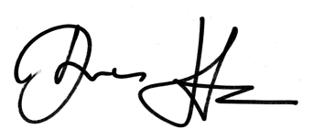
Best regards

